Scholarship Application

1) What would be helpful to you? Check ✓ all that apply.

We would like ______one-day passes.

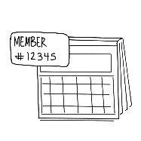
We would like a yearly membership.

We would like a discount of:
- 25%
- 50%
- 75%
- 100%

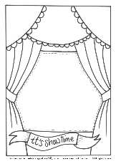
We would like ________ free tickets for theatre shows.

Keep an eye on kitetails.org/theatre for the schedule of pay-what-you-can theatre showings!

2) Tell us why this scholarship would be helpful for you
________________________________________________________
________________________________________________________

3) Please fill-out with information on 2-9 people:

Adult Name 1: __________________________________________
(ex. Jane Smith)

Adult Name 2: __________________________________________
(Optional)

Adult Name 3: __________________________________________
(Optional)

Children’s Names: Birth Dates:
(ex. 01/01/1999)
___________________________________ _____________ ___________________________________ _____________
___________________________________ _____________
___________________________________ _____________
___________________________________ _____________
___________________________________ _____________

Space for more names on the back!
Phone number:
_________________________________________
ex. (207)555-5555
E-mail: ___________________________________

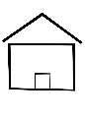
Current address: __________________________________________
__________________________________________
City:_________________State:____Zip:_________

How did you hear about this program?
(friend/family, web, service, etc…)

_____________________________________________________________

More Family Members (your membership can include up to 4 adults):

Adult Name 4: __________________________________________
(Optional)

Children’s Names: Birth Dates:
(ex. 01/01/1999)
___________________________________ _____________

___________________________________ _____________

___________________________________ _____________

More space for your story:

______________________________________________________
______________________________________________________

______________________________________________________
______________________________________________________
______________________________________________________
______________________________________________________
______________________________________________________
______________________________________________________

______________________________________________________

Today’s date: FIN:

