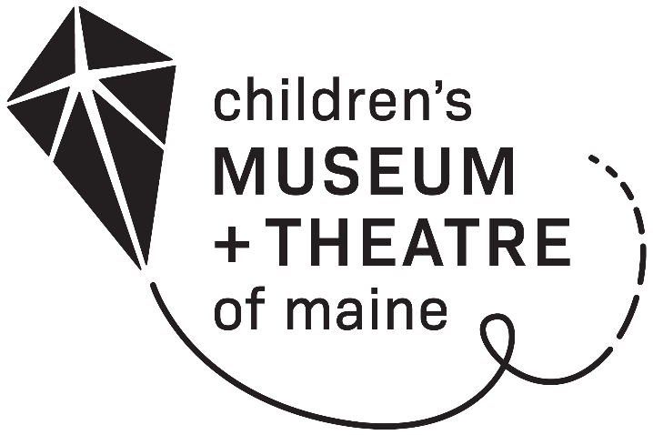
LIBRARY
MEMBERSHIP

A membership program at the Children's Museum & Theatre of Maine for libraries and their members.
Limit one per library.

COST: $150 for a one-year membership

BENEFITS:

- 50% discount on general admission for up to four people per day
- A calendar to keep track of when your pass is checked out
- A sign for your front desk or bulletin board

TO APPLY:

Contact Person: ___________________________ Contact Phone: ______________

Contact Email: _______________________________________________________

Library Name: ____________________________________________________

Library Address: ___________________________________________________

Library Phone: ____________________________________________________

Name of Organization as you would like it to appear on membership (If different from above):

_________________________________________________________________________

Please return form with payment to:
Children’s Museum & Theatre of Maine
250 Thompson’s Point Road
Portland ME 04102

To sign-up or renew via phone, please call (207) 828-1234 x290.

Library Membership Policies

- A library pass entitles the holder to 50% off Museum admission to the Children's Museum & Theatre of Maine for up to 4 people per day. The pass may only be used once per day.

- To use the pass, members must present a photocopy of the pass itself placed on the guideline sheet. The pass should be placed so that the membership information (library name, membership expiration date, etc.) is visible.

- The pass must be signed by an authorized representative of the library and dated with the date of intended use.

- The pass is not valid on the first Friday of each month when the Museum & Theatre offers $2 admission from 5 p.m. - 8 p.m.

- Visitors using the pass are welcome to attend any and all programs that are free with admission. The pass is not valid for theatre productions or paid programs and does not entitle the holder to members-only events or benefits.

- If you’d like to bring a group of ten or more visitors to the Museum with your membership, please call 828-1234 x290 at least 24 hours in advance to reserve your space.

